Dharshini S 241901026

Exp no:1A Date: 15/08/2025

BASIC NETWORKING COMMANDS IN WINDOWS OPERATING SYSTEM

Aim:

To study basic networking commands in windows operating system.

The Windows operating system provides its user with a powerful tool, Command Prompt, which allows the user to access and configure system settings and data.The network commands prove helpful when there is a need to configure or troubleshoot the network settings of our system.

ROUTE

Provides the data of routing data packets in the system over the communication channel. Command to enter in Prompt - route print

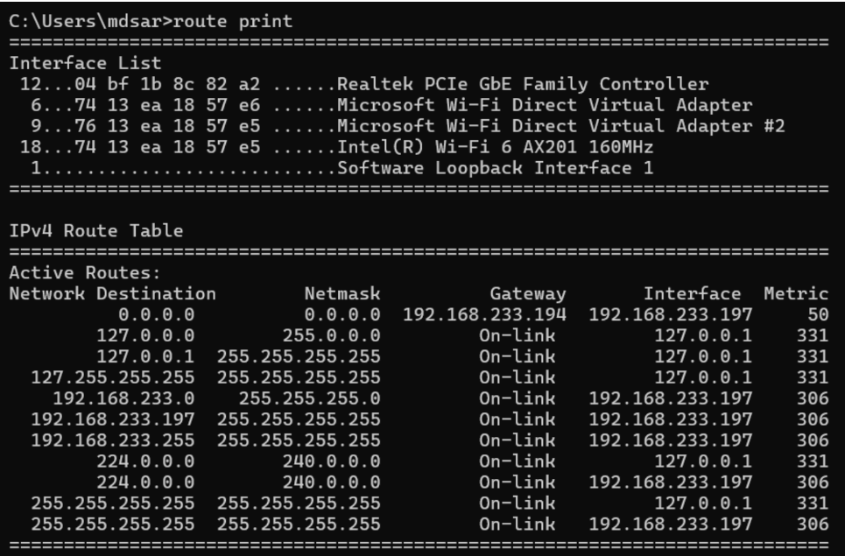

NETSTAT

The Netstat command as the name suggests displays an overview of all the network connections in the device. The table shows detail about the connection protocol, address, and the current state of the network.

Command to enter in Prompt – netstat

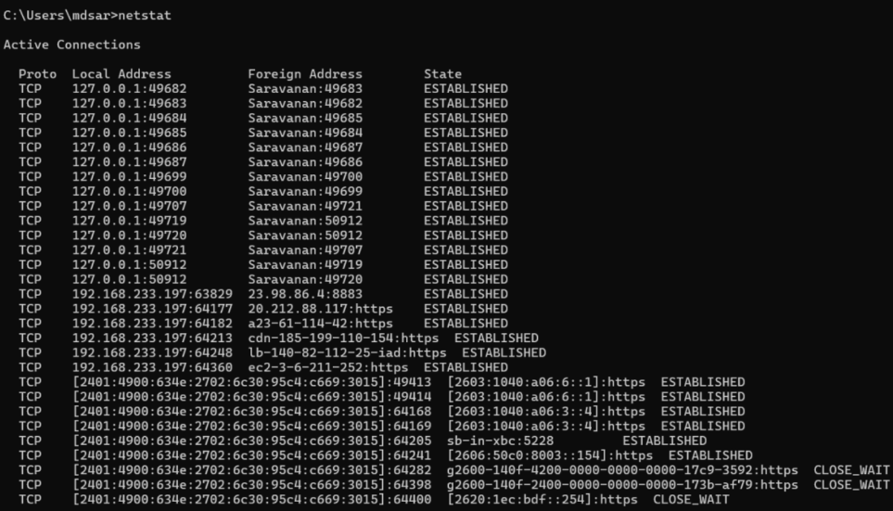

SYSTEMINFO

Using the SYSTEMINFO command, we can access the system's hardware and software details, such as processor data, booting data, Windows version, etc.

Command to enter in Prompt - systeminfo 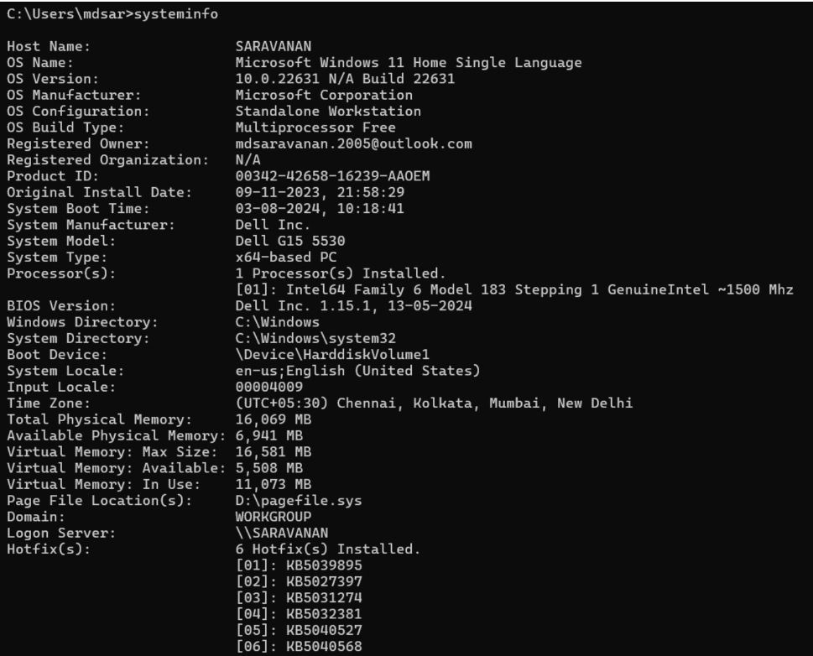

ARP(Address Resolution Protocol)

The ARP command is used to access the mapping structure of IP addresses to the MAC address. This provides us with a better understanding of the transmission of packets in the network channel.

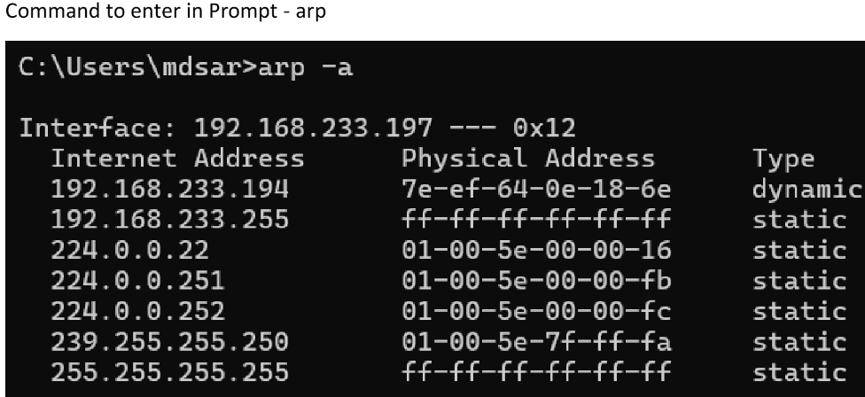

PING

The Ping command is one of the most widely used commands in the prompt tool, as it allows the user to check the connectivity of our system to another host.

This command sends four experimental packets to the destination host to check whether it receives them successfully, if so, then, we can communicate with the destination host. But in case the packets have not been received, that means, no communication can be established with the destination host.

Command to enter in Prompt - ping [www.destination_host_name.com](http://www.destination_host_name.com)

